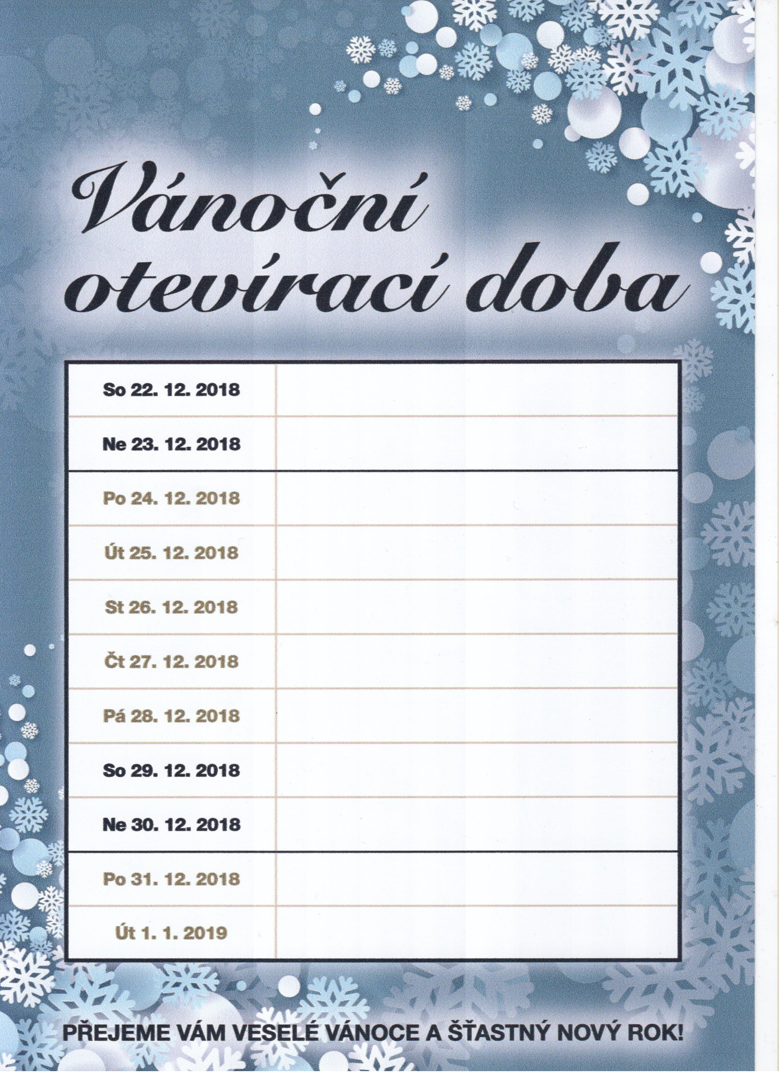

11:00 – 24:00

11:00 – 17:00

-
-
11:00 – 23:00

11:00 – 23:00
11:00 – 24:00

11:00 – 24:00
11:00 – 22:00

-
-

